How to manage side effects

Eating well while taking GLP-1 and GIP mimetics
These medications mimic the hormones GLP-1 and GIP that our body naturally produces to release insulin and to promote feeling full.
This leaflet aims to help you manage possible side effects and provides information to help you stay well-nourished while taking them.
GLP-1’s will help your diabetes in 4 ways:

Not everyone experiences these symptoms, and they usually improve once you are established on the medication. These side effects may impact your daily life and prevent you from eating well and carrying out day-to-day activities that you enjoy.

Possible side effects of the treatment
- Nausea
- Constipation
- Diarrhoea
- Bloating
- Headaches

- Tell your brain when you are satiated (feeling full) to prevent overeating and encourage weight loss.
- Lower the amount of sugar being released from the liver into the bloodstream.
- Stimulates the pancreas to release insulin.
- Slows down the rate of food leaving the stomach.
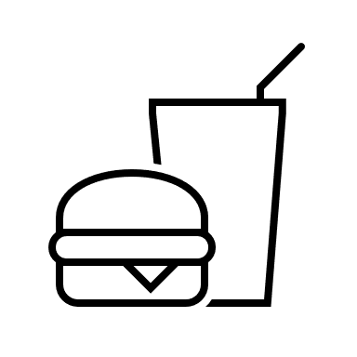
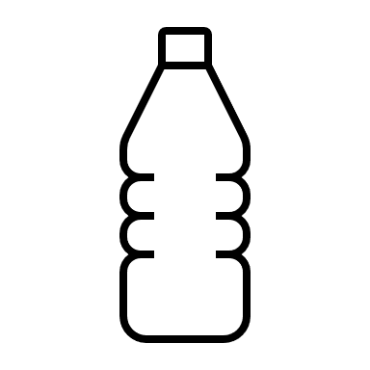
Avoid fatty and spicy foods

Have 6-8 glasses of fluid a day.



Avoid consuming alcohol
Reduce portion sizes by using smaller plates.
Other ways to manage side effects include:
- Sitting upright when eating, not lying down for a while after,
- Stop eating when you feel full
- Eat smaller more frequent meals. Chew food well and eat slowly
- Get plenty of fresh air. A short walk before a meal may help.
- Drink ginger or peppermint tea and take regular sips of a cold clear drinks
- Distract yourself by doing something you enjoy
Increase protein Protein protects against muscle loss when losing weight. It is essential for repairing damaged tissues and maintaining a healthy immune system. Protein needs are often increased in older people over 65 years old, and those who are unwell. Protein is satiating, meaning it keeps us fuller for longer to help reduce snacking.
Examples of foods higher in protein are beans, lentils, poultry, meat, fish, eggs, dairy food, some diary alternatives, mycoprotein (Quorn) and nuts. Try to have a portion of foods higher in protein at 2-3 meals daily.
- Choose lean sources most of the time
- Increase plant-based foods such as beans, lentils and chickpeas.
- Ideally ¼ of your plate at your main meal will contain some kind of protein!
- Resistance training helps maintain muscle mass and strength. Examples include lifting weights, working with resistance bands, heavy gardening, such as digging and shovelling, climbing stairs, hill walking, cycling, dance, push-ups, sit-ups and squats, yoga and Pilates
Fruit and vegetables Including fibre in your diet is important for our bowel health, particularly reducing the risk of developing bowel cancer and cardiovascular disease.
- Vegetables - fill ½ of your plate if tolerated
- Fruit contains natural sugars that increase your blood glucose – only have one portion of fruit at a time and spread it out through the day
- A diet high in fibre will also help with constipation, as fibre helps soften stools, making them easier to pass.
- Keep hydrated to prevent dehydration as fibre in stools will absorb water.

Starchy Carbohydrate This is our body’s main energy source as it turns into glucose when digested. Foods containing carbs have the biggest impact on blood glucose, so it is important to be mindful of the type and the portion size.
- Choose wholegrain starchy foods such as seeded bread, pasta, oats and rice as the glucose from these is released more slowly into the body which helps you feel full for longer.
- Keep to a fist size portion or ¼ of your plate, i.e. one jacket potato, fist size serving of pasta.
Reduce high fat foods Saturated fat increases our LDL cholesterol, which can increase the risk of having a stroke and heart disease. Fat is the highest calorie nutrient so having too much can lead to excess weight around your middle that can cause insulin resistance.
- Choose low fat mayonnaise, yoghurts and salad dressings.
- Use oils such as rapeseed, sunflower or olive oil sparingly.
- Prioritise healthy fats found in nuts, seeds and avocado, but keep portion sizes small.
- Include sources of omega 3 found in oily fish, nuts, seeds and soya for our brain and heart health.
- Limit fattier meats like sausages, burgers and choose reduced fat options.
- Reduce ‘treats’ like crisps, desserts, cakes, chocolate and cream
Multivitamins and minerals should only be required if you are unable to eat properly, except for Vitamin D (minimum dose 10 μg/400 IU daily) October to March – seek personal advice)

What to eat when taking a taking GLP-1 and GIP mimetics
Although these medications often reduce appetite it is important to eat healthily. Please see the suggestions below and ask to see a dietitian if you find you are unable to eat well enough.

